1. Launch **Value Navigator 6.4 - Test** application

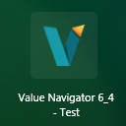

1. Below window appears. Click **Close**

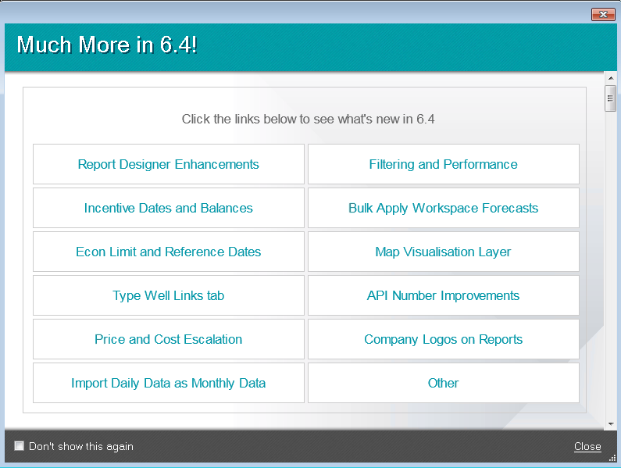

1. Click **Cancel** button to close the Project Launcher

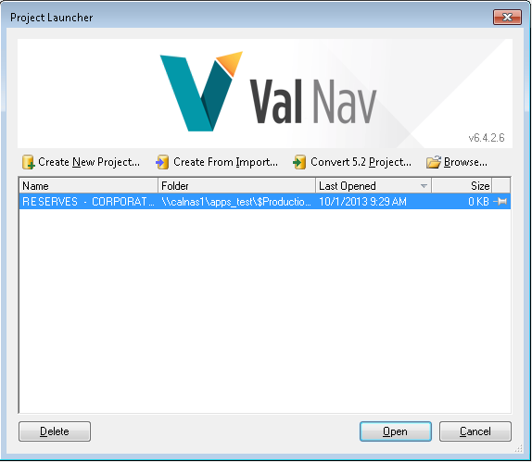

1. Go File -> Navigate to “Edit or Create Project Connection File”

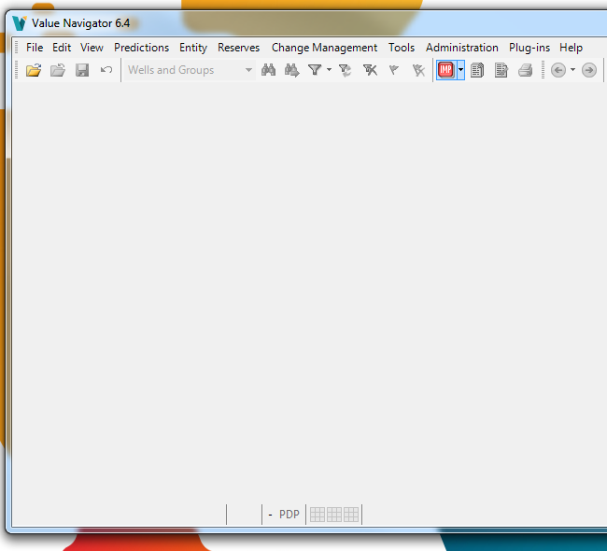

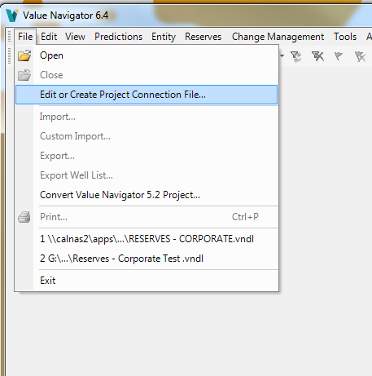

1. This will open the “Project Connection Information”

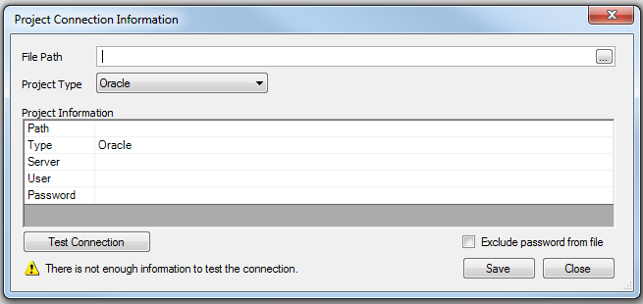

1. Navigate to Test vndl file (\\calnas1\apps_test\$ProductionApps\Programs\ValueNavigator\Prod\DB Links\RESERVES - CORPORATE.vndl )
2. Click “Test Connection”  
   The “Connection established” message indicates that the application is connecting to the database successfully

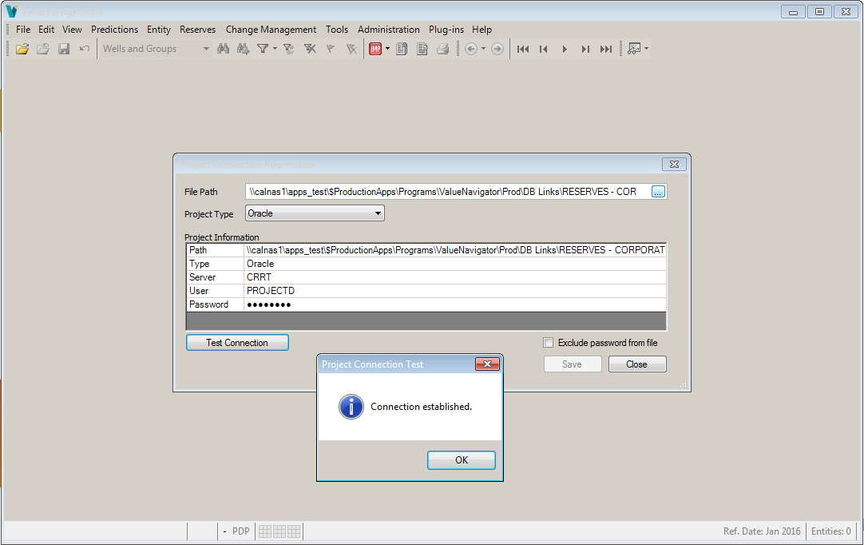

1. Click on Help -> License manager.  
   Verify the license path.

